Papilio quick start guide

This guide will demonstrate how to generate and load a bit file to the Papilio 500k as well as loading code to the ZPUino soft processor. You will need at least 26 Gb of space on your hard drive for the Xilinx design suite for the installer file as well as the installed software. You will also need to register with Xilinx on their website to get a free license key to use the design suite

Step 0 - Download

To use the papilio you will need the Papilio Loader GUI 2.6, Xilinx ISE Design Suite 14.7, Papilio Schematic Library 1.6, and ZAP IDE 2.3.0.

These can be found here:
http://forum.gadgetfactory.net/index.php?/files/file/10-papilio-loader-gui/
http://www.xilinx.com/support/download/index.html/content/xilinx/en/downloadNav/design-tools.html
http://forum.gadgetfactory.net/index.php?/files/file/47-papilio-schematic-library/
http://forum.gadgetfactory.net/index.php?/files/file/8-zap-zpuino-arduino-papilio-ide/

The ZPUino IDE CAN NOT be placed in a folder with spaces in it's name. If it is it will not start and will return an error.

Please note that in the event of a large software update this guide may no longer be valid as the software is constantly changing and having features added.

Step 1 - Installation

To begin, we need to install the ISE Design suite and Papilio Loader GUI.

A short guide on installing the design suite can be found here: http://gadgetfactory.net/learn/2013/10/23/install-xilinxs-free-ise-webpack/.

To install the loader, go to http://forum.gadgetfactory.net/index.php?/files/file/10-papilio-loader-gui/ and click the green Download button at the top right of the page. Select the Papilio-Loader-2.6-Setup.zip file and unzip it. Run the Papilio Loader-2.6-Setup.exe installer and click through the installer options. We will leave everything at the default settings for this guide.

Step 2 - Project Setup

Now that we have the necessary software installed we will start to work from the Papilio Sechematic Library downloaded in step 0. Next we need to navigate to the Papilio-Schematic-Library-1.6\examples\Template_PSL_Base directory of the schematic library. This is the base template of the ZPUino soft processor we will be using.
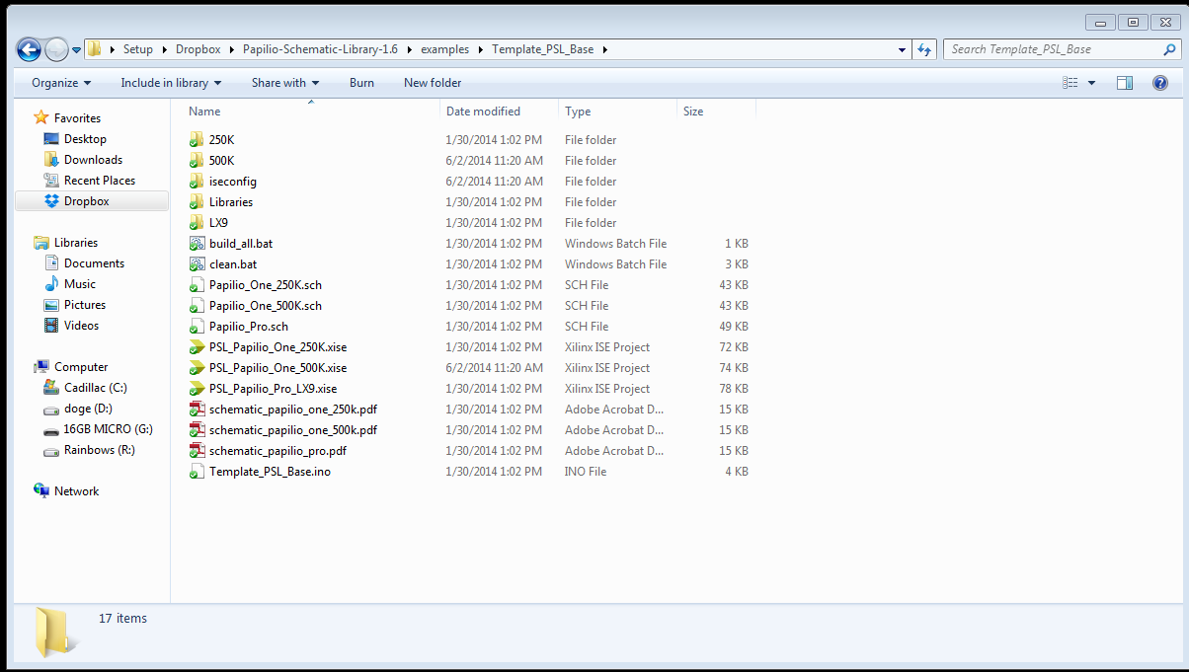
Double click the file labeled PSL_Papilio_One_500k.xise to open the Xilinx ISE Project Navigator.

Since we are going to be making changes to this file and want to use this template again we want to make sure we make a copy somewhere else. Navigate to the File drop down and click copy project.
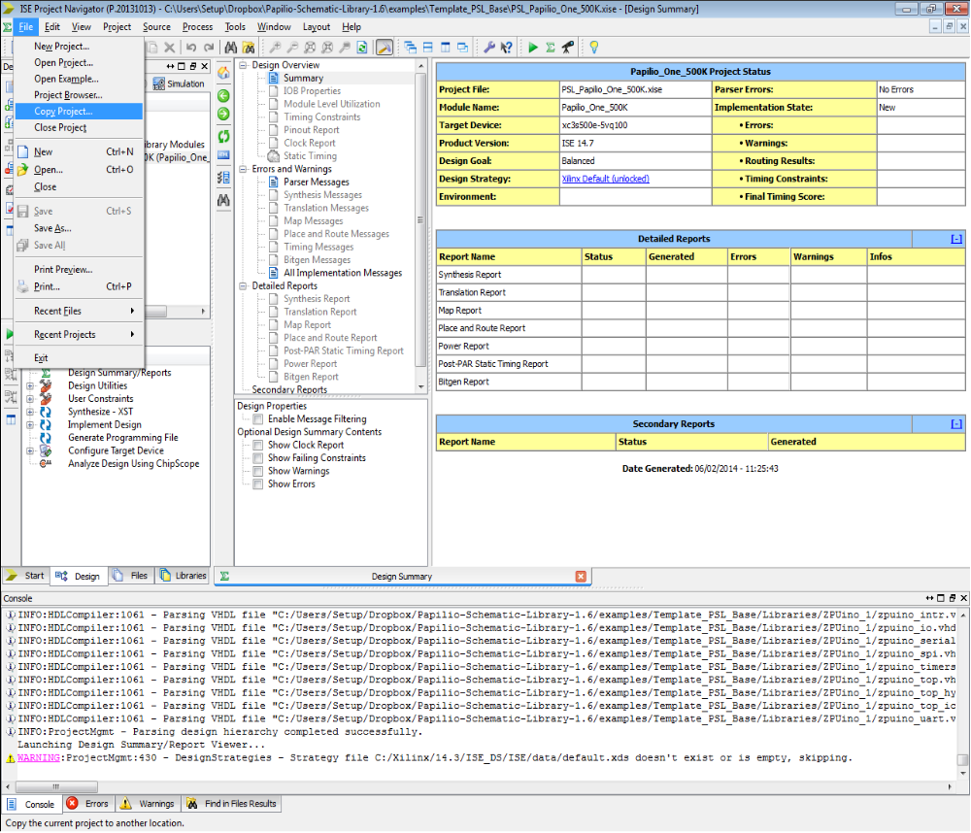
A Copy Project dialogue box will appear. We need to specify a new project name and location. For the sake of this tutorial we will use the name Tutorial, and place it directly in the schematic library folder (Papilio-Schematic-Library-1.6) to avoid confusion with other files.
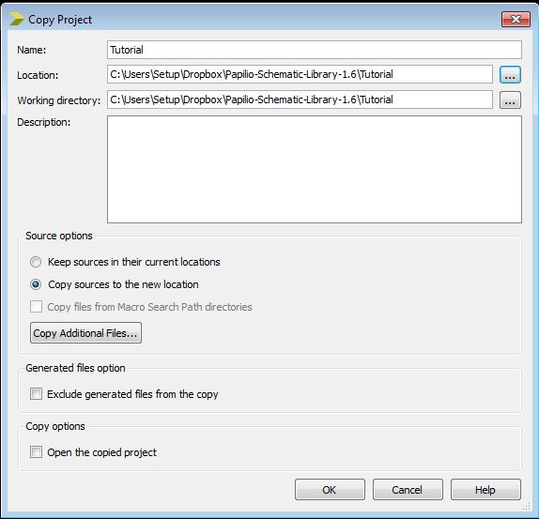

Now that we have our new project close the template and navigate to the Papilio-Schematic-Library folder. We should have a new folder inside of it named Tutorial.
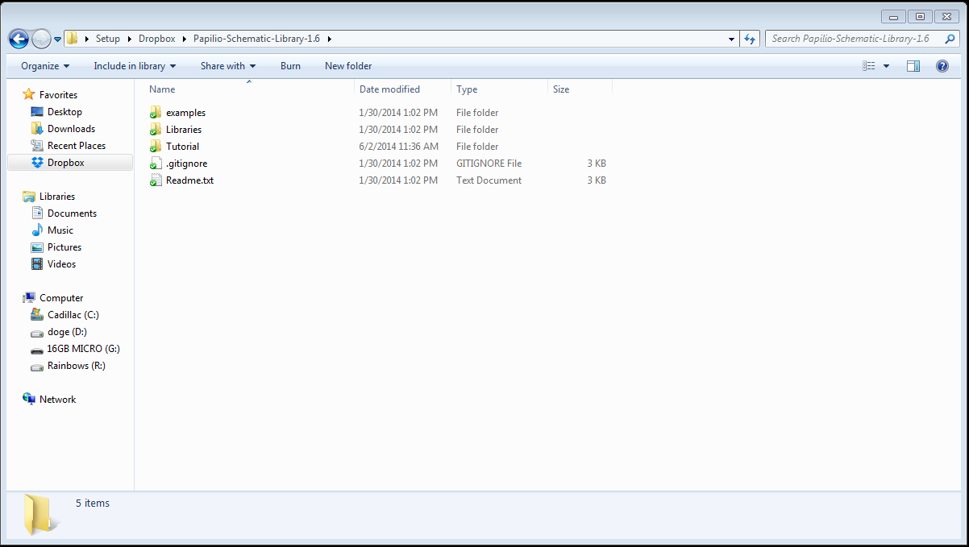
Inside the folder should look like this. Don't worry if there are other files in the folder, just check to make sure the one's shown below are there.
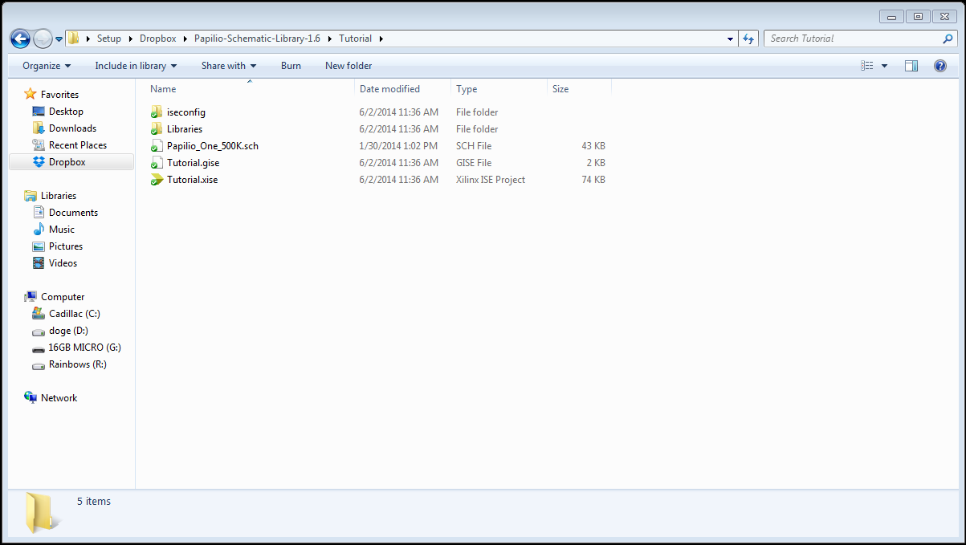
We can now launch the file Tutorial.xise to view our new project.

Now that we have Tutorial.xise open we need to view the ZPUino soft processor. We can do this by double clicking on the Papilio_One_500k.sch file in the Hierarchy box
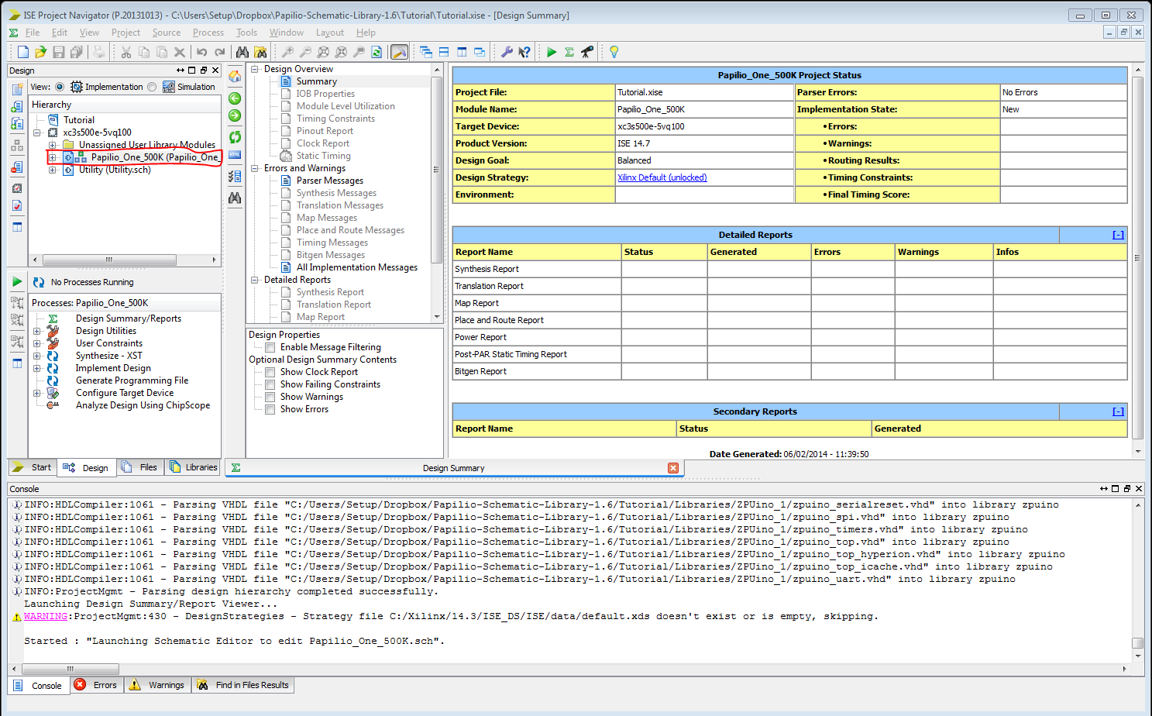
A new tab will open up next to the Design Summary tab over the Console box. This is displaying the ZPUino soft processor that we are running on the Papilio.

Now that we have the schematic open we need to point the ISE Project Navigator to the schematic symbol library foler. Without the symbol library we can not build anything in our project. Unfortunately, when we copied the project it did not copy the Xilinx_Symbol_Library folder along with it. Because of this we are left with two options: Point to a symbol library outside of our project, or move the symbol library into our project. Since we plan on editing and sharing this project we should add the symbol library to it's folder for later use.

We now need to navigate back to the base template file we opened earlier and open the Libraries folder. Once we are in the Papilio-Schematic-Library-1.6\examples\Template_PSL_Base\Libraries directory we need to copy and paste the Xilinx_Symbol_Library into the Tutorial\libraries folder (the libraries folder within the Tutorial folder we created earlier) .
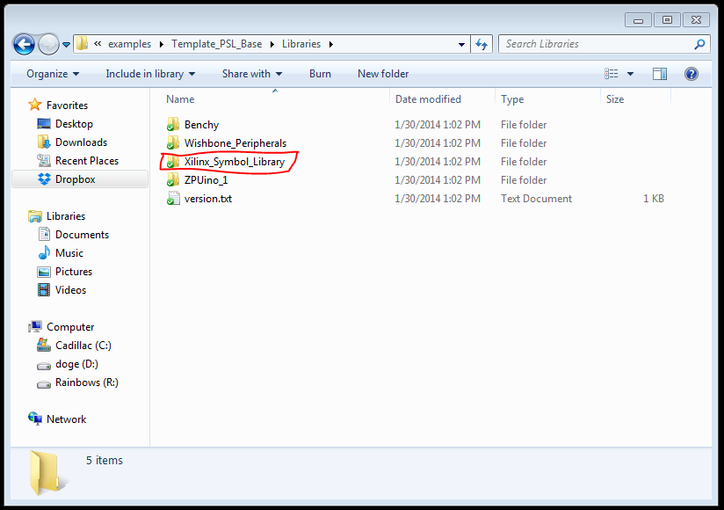
Now that we have added the Xilinx_Symbol library to the Papilio-Schematic-Library-1.6\Tutorial\Libraries file we can continue where we left off in the ISE Project Navigator.

To add the schematic symbol library we need to navigate to the Tools drop-down and click Symbol Library Manager near the bottom
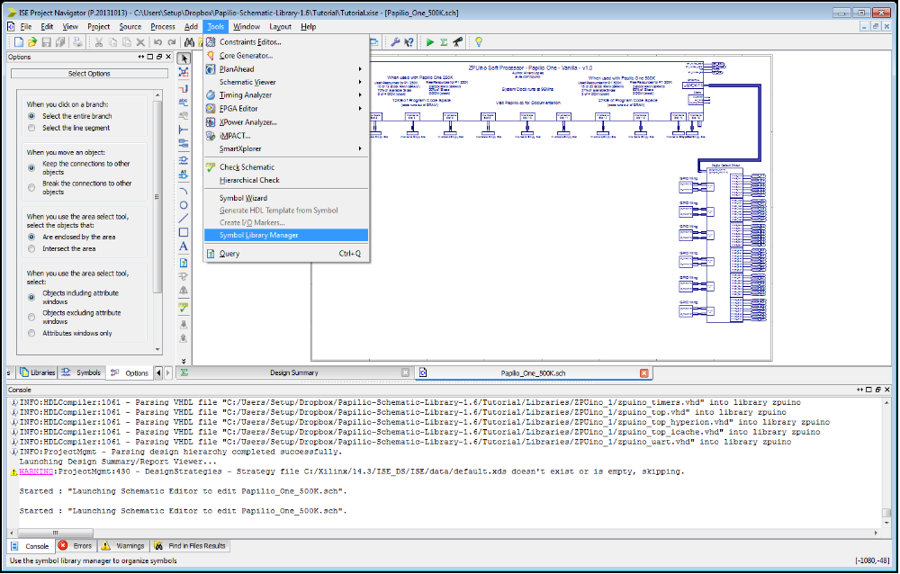

We now need to click browse next to library file name and navigate to the Xilinx Symbol Library. Select the .lib file inside of it and click open. We also need to navigate to the same file location for the schematic drawing path in the box below. When you hit Browse for the Schematic drawing path it should navigate to the same file location as in the library file name field, but if it does not do this on it's own you will need to get there manually.
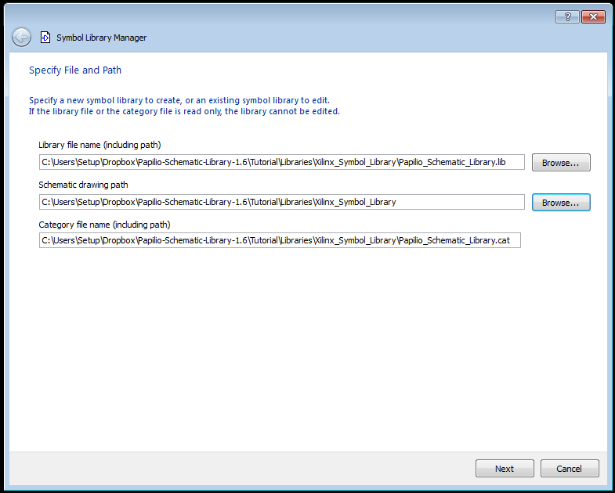

Once we have specified the files we need to click Next. Sometimes the Next button is hidden from view and the window will need to be expanded to view it.

Click Next on all of the menus until you reach the Specify Device Family page. Click the Check All button and then continue clicking Next.

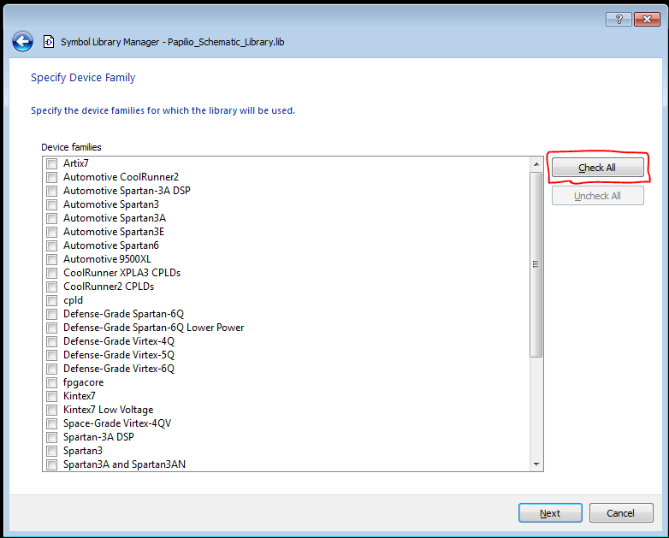

We have now finished the setup process on how to create a bit file for the Papilio 500k

Step 3 – Bit file generation

Now that we have set up the software we can create a test bit file that we can flash to our Papilios to test them and make sure we followed the steps correctly.

Start by navigating to the design menu using the left arrow button to scroll through the options at the side and clicking Design
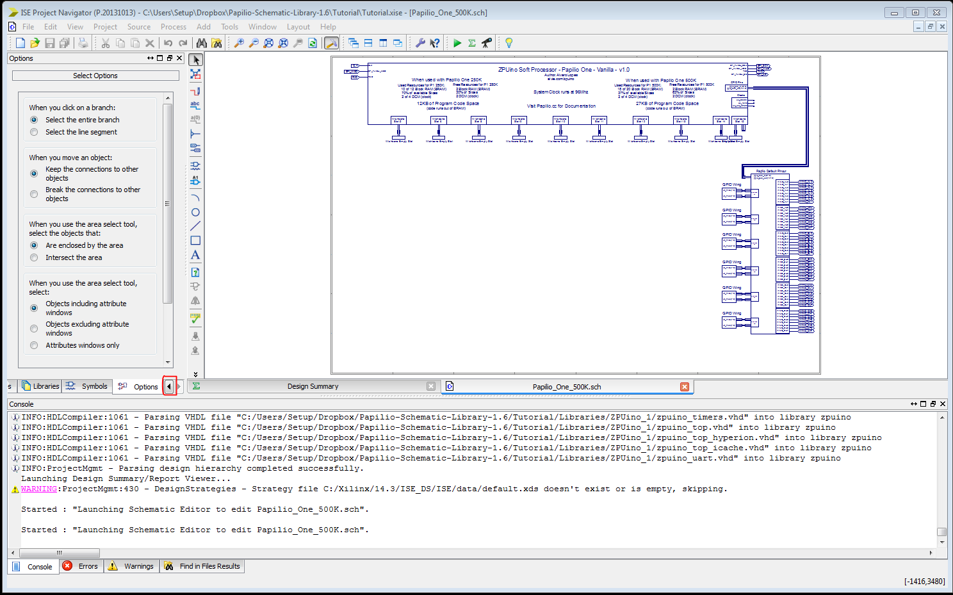
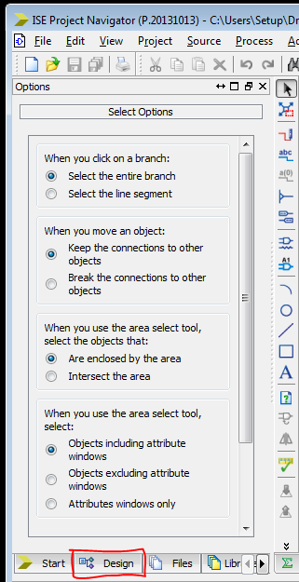

Now that we are at the Design page we need to click on the Papilio_One_500k text in the Hierarchy box to ensure it is selected and double click Generate Programming File to start the generation process.

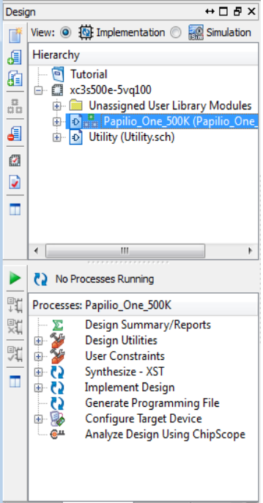
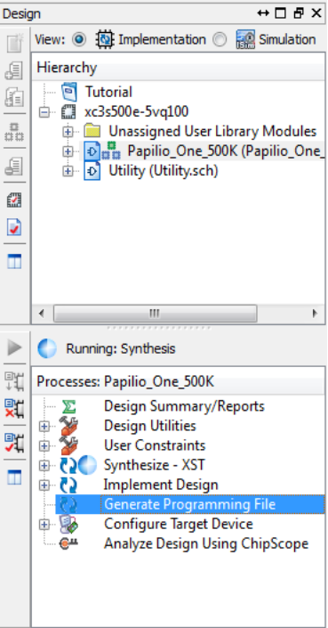

Bit file generation may take a while – on a laptop it generally takes at least 15 minutes while on a more powerful desktop it can take as little as two minutes. It also is normal to see a number of warnings in the console as generation occurs, as the Papilio schematic library is incomplete. These warnings do not prevent the bit file from generating properly and can be safely ignored under most circumstances.

Step 4 – Flashing the Papilio

If you have not doe so already, plug the papilio into the usb port on the computer using the mini usb cable.

Now that we have a bit file for the Papilio we can write this to the Papilio using the Papilio Loader GUI installed in step 0. To do this navigate to the Papilio-Schematic-Library-1.6\Tutorial directory and find the file named papilio_one_500k.bit. Right click on this file and click 'Write permenantly to Papilio Board'.
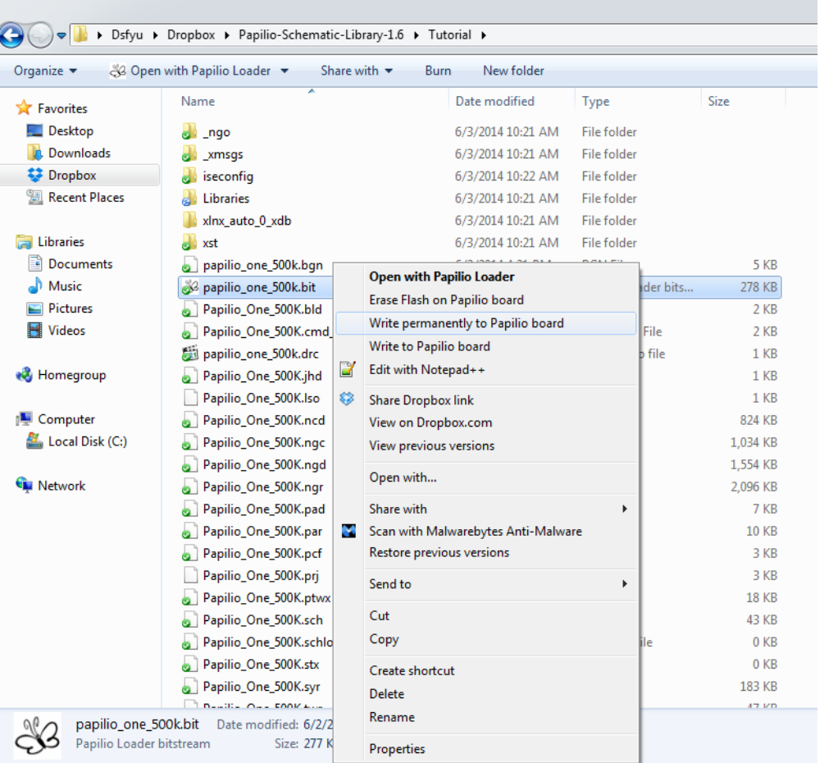
A new window should open up and should automatically start writing to the Papilio. If it does not you should ensure it is set to write to SPI Flash and then click Run.
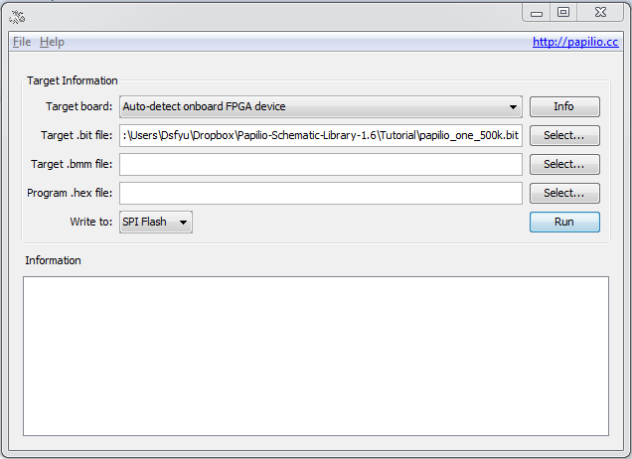

The Papilio should now be loaded with a bit file and should be ready to run code in ZAP.

Step 5 – Loading code through ZAP

Now that the Papilio has been loaded with a bit file we can use the ZAP IDE to write code and load it to the ZPUino soft processor.

First, navigate to the directory where you placed the papilio-zap-ide file, and run the zap.exe application inside.
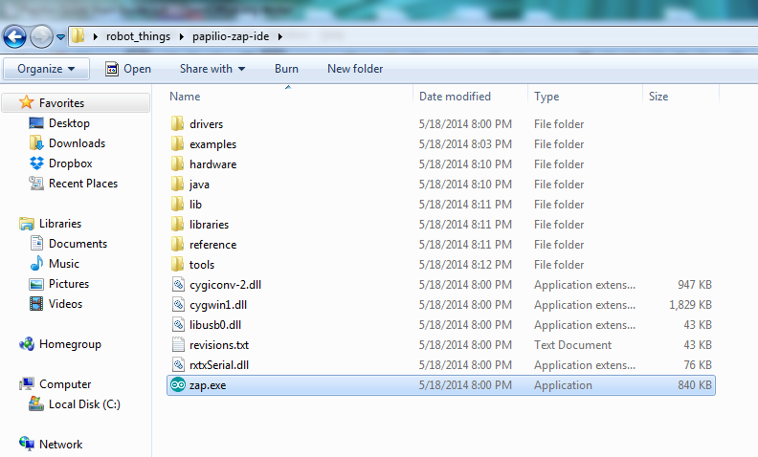
You should see a new window similar to the arduino IDE like the one below
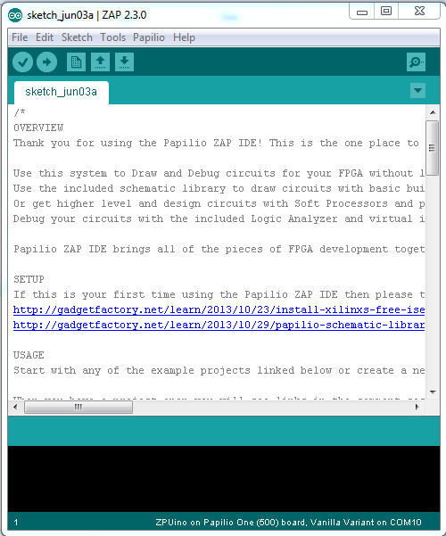

To get started we must write a simple program for it. For the sake of this tutorial we will only write the bare minimum for it to upload code. The code and a screenshot of this follows below.
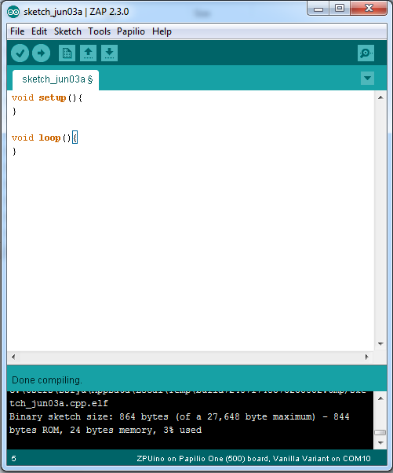

void setup(){
}

void loop(){
}

Now that we have the bare minimum code to write to the Papilio we need to set the serial port it communicates over when writing as well as how to write to the board. First we set the serial port by going to the tools drop-down, navigating to serial port and selecting the second COM port – the numbers vary depending on which USB port the Papilio is plugged into on your computer and the COM ports come in pairs.
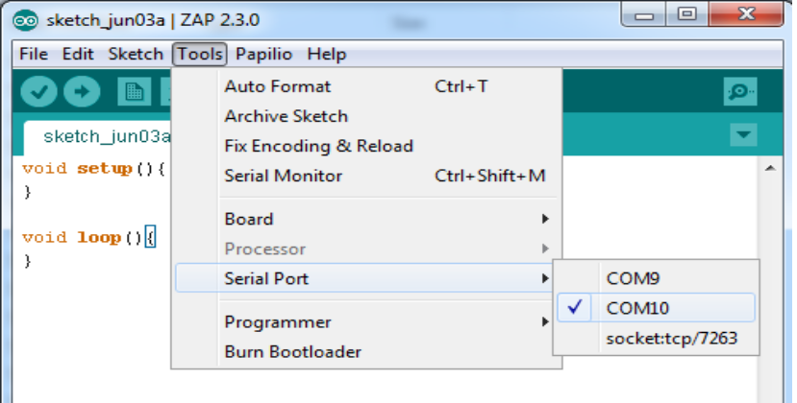

Now that we have selected the serial port to communicate over we need to set the board we are using. For this tutorial we are using the Papilio 500k and should make the selection accordingly. Again, we need to navigate to the tools drop-down, and select Board, then ZPUino 1.0, and ZPUino on Papilio One (500) board, Vanilla Variant
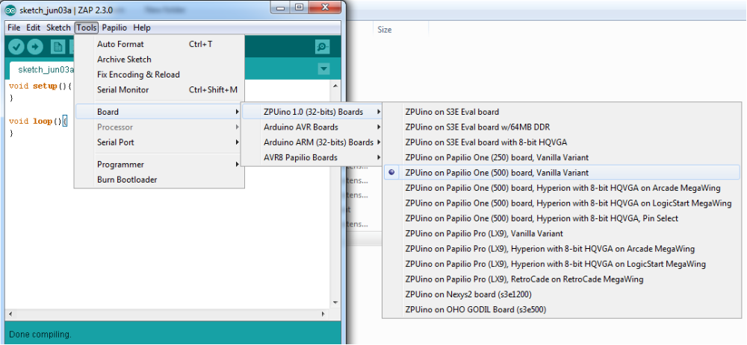
Now that we have selected the type of board the last thing we need to do before programming the ZPUino soft processor is make sure we have the correct Programmer selected. In the same Tools menu navigate to the Programmer tab and ensure that the Papilio Programmer option is selected.
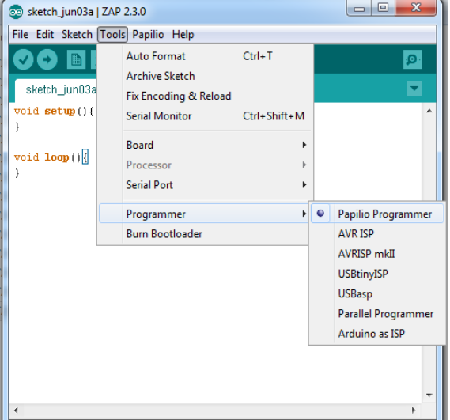

Now that we have the ZAP IDE set up we can upload directly to the Papilio with the upload button next to the check mark at the top left.

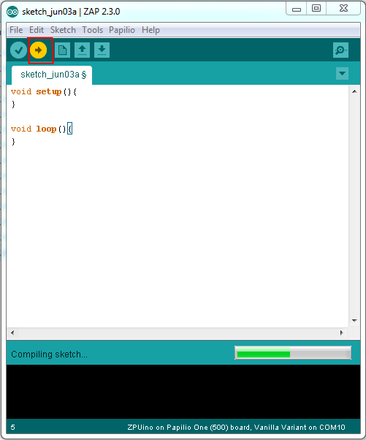

Congratulations! You have successfully generated a bit file, written it to the Papilio, written code for the ZPUino soft processor, and uploaded it to the ZPUino soft processor!

